Welcome!
Date
Name
Spouse
Address
City
State Zip _________
Email

Please Contact By
❑ Card  Phone  Visit

Telephone Best Time to Call
Home ______________
Work ______________

Guest: First Time Second Time
Are you a church member: yes no
Church
City, State

Circle Appropriate Age/Grade Group(s)
Preschool: Ages: B-1 2-3 4-5
Children: Grades: K 1 2 3 4 5 6
Youth: Grades: 7 8 9 10 11 12
Adults: Ages:18-29 30s 40s 50s 60s+

How did you learn about our church?
Newspaper Friend Yellow Pages Mail
Other

I am a guest of:

New in the Community? Yes No
Names & ages of children at home

Weekly Service & Activity Schedule
March 2, 2014
9:45 a.m. Sunday School
11 a.m. Morning Worship

5 p.m. Kids in Action
6 p.m. Evening Service

Week of March 3 – March 8

WEEK OF PRAYER FOR NORTH AMERICAN MISSIONS
ANNIE ARMSTRONG OFFERING

Monday, 6:30 p.m. Healing Our Community Prayer Night
Monday, 7:00 p.m. Youth at FBC Lexington
Wednesday, 6:30 p.m. Youth Activities
Wednesday, 6:45 p.m. Adult Prayer & Bible Study
Wednesday, 7:30 p.m. Praise Team Rehearsal
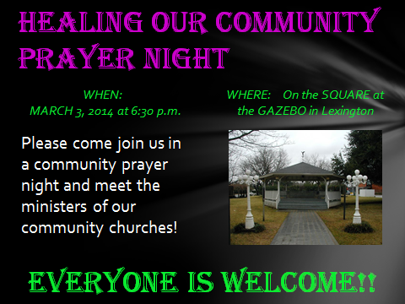


Upcoming Events
March
3 Healing Our Community Prayer Night
3 Youth at FBC Lexington
9 Daylight Savings Time Begins (Spring Forward)
9 Church Council Meeting (5 pm)
9 Business Meeting
13 Adult Fellowship
16 “One Voice” Mary Hardin Baylor Choir
27 Adult Fellowship
30 Movie night
Birthday & Anniversary Recognitions will occur on the final Sunday of each month.

Knobbs Springs Baptist Church

Do you not know
that in a race all the runners run,
but only one gets the prize?
Run in such a way as to get the prize.
Everyone who competes in the games
goes into strict training.
They do it to get a crown that will not last,
but we do it to get a crown that will last forever.
Therefore I do not run
like someone running aimlessly;
I do not fight like a boxer beating the air.
No, I strike a blow to my body and
make it my slave
so that after I have preached to others,
I myself will not be disqualified for the prize.
1 Corinthians 9:24-27

March 2, 2014

Church Information:

KnobbsSpringsBC.com KnobbsSpringsBaptist@gmail.com
1662 CR 305, McDade, Texas 78650 512-273-2743
Brother Dwight Reagan 512-247-6448
Kimberly Tabor, Office Manager 512-698-2804

